Report on Hotel Management Website

**Members –** Prabhat Kumar (12214535), Naman Sharma (12214594) , Amarnath Tripathi(12208915)

**Section**-K22RZ

**Roll** **No** – 40 , 41 , 64

**Subject** **Code** – CSE – 326

**Submitted** **To** - Mr. Mohammad Faiz

**Acknowledgement**

We would stop shortly to thank all those who devoted their energy, resources and time

to the success of this project. The foremost ultimate thank you goes to my determined and ever

encouraging computer studies teacher MR. Mohammad Faiz. No words can explain my gratitude

for your ever helping hand through this process. However, I can’t forget the support that both my

University administration and my family have granted me through this process. In conclusion, We will ever treasure the help from both mentioned and non-mentioned well-wishers

deeply in their hear.

**Abstract**

This project aims at creating on Hotel Management System which can be used by Admin and Customers. The admin to advise/publish the availability of rooms in different hotels and customers are checking the availability of room in required hotel. Customers should be able to know the availability of the rooms on a particular date to reserve in hotel. They should be able to reserve the available rooms according to their need in advance to make their stay comfortable.

The Admin hands the booking information of customers. The users can register and log into the system. The administrator will know the details of reservation and daily income. The hotel department maintain the seat availability and booking details in certain database. This project provides high security to Admin and user information**.**

**KeyWords :** Hotel , Palm Tree , Website , Bookings , Holiday and work Stay , Beautiful and Lovely sights.

**Introduction**

Palm Tree Hotel management System was developed following system development stages

for smooth running and management of ABC hotel. The seven months provided by the Kenya

national examination council enabled the system analyst recognize and define the problem in the

current manual system at the hotel. After an information gathering process from several hotels

managed by manual and computerized systems, the system analyst saw that the hotel indeed

needed a computerized management system.

After a close analysis of samples collected during the problem definition stage the analyst found

that all the hardware and software requirements needed for implementation and maintenance of

the system are readily available in the market and cheaply affordable by the hotel. The system

was carefully designed to ensure maximum efficiency of the system at the hotel. The system was

Skillfully and carefully coded to seal any possible loopholes in the system.

The system was developed using visual basic for applications (Microsoft access) language. This

system will indeed help the hotel management and the esteemed staff members to manage and

steer the hotel’s functionality and transactions to realize its maximum potential in addition to its

competence in the hotel business field.

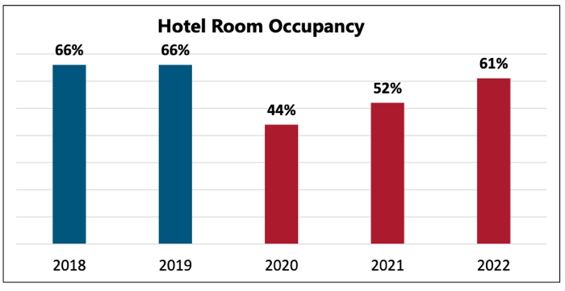

**Fig. 1**: Total no. of Variation in Room Occupancy from 2018 – 2022

**Related Work**

Hotelogix by HMS InfoTech is a versatile, spectacular hotel management that incorporates each

application a little or medium-sized accommodation business should be effective in present

focused market. This powerful, cloud-based arrangement is obviously appropriate for developing

autonomous lodgings, hotels, cabins, resorts, and other property types that are looking for a

moderate model that can be set up rapidly and effectively, with no enormous forthright

speculation.

Basic applications incorporate hearty front desk operations, Point of Sale, housekeeping, and

that's only the tip of the iceberg. Structured utilizing the most recent online advances, the

framework's neighbourly and graphical UI disentangles and streamlines basic regular

assignments. It's additionally very easy to understand, so lodging staff can be fully operational

rapidly with next to zero vacation.

At the centre of the framework is a thorough Property Management System (PMS) that supports

numerous properties as well as different monetary standards, making this an incredible fit for

organizations with a shifted geological impression. From this brought together centre point

clients can then effectively get to different modules: reservations, MIS or eating administrations,

and even the hotel site, all from a solitary bound together stage.

The system can be incorporated with all significant charge card instalment entryways, just as

other outsider mixes for outer CRS's, EPBAX, bookkeeping, and then some. The device used to

build up this application is PHP.

Hotel Pro group accompanies an extreme development in Hotel Management. The likelihood to

oversee more than one structure from a similar application with Multi-Property the executives.

This online electronic arrangement isn't just a device for better online reservations; it is an

application which gives a few highlights, including solicitations, available reports of the

convenience's unit and the plausibility of publicizing inn benefits through various channels like

SMS, email, Facebook and Twitter.

Consolidating openness with adaptability, Hotel Pro offers the chance to create advancements

from a similar application, utilizing either the advertising instrument or the POS module where

hoteliers can characterize new administrations and items.

**Novelty of the Work**

The management and booking of Rooms in hotels is a tedious and complicated task especially if it is done manually. Keeping track of large customers and all their details requires an inordinate space for file cabinets, not to mention the time the hotel administrator would spend going back and forth to file cabinets so as to look up each customer’s information. This is why a good hotel reservation system is needed to make this task as easy as possible. But we all know that in India most of the people don’t use online websites for hotel or resort bookings. This is a new thing in india and it is spreading widely in india too.

**Proposed Model**

The proposed model contains some additional advanced features that can be included in the hotel management website to make it a more user-friendly and responsive. The model consists of a few steps to be followed by the user, such as after entering the homepage, the user needs to register itself by entering its basic details as per the section mentioned, the authentication process is completed. And if not, the user is asked to restart from the beginning. Once the user details are verified, the user can access the room that user choose it. Also if user will input no username then there will be a alert prompt saying the “USERNAME CANT BE EMPTY” , also if the password is less than 8 digit another alert will be prompted saying: “PASSWORD MUST CONTAIN 8 DIGITS”.

The mechanism of the proposed model is shown in the below-mentioned flowchart: 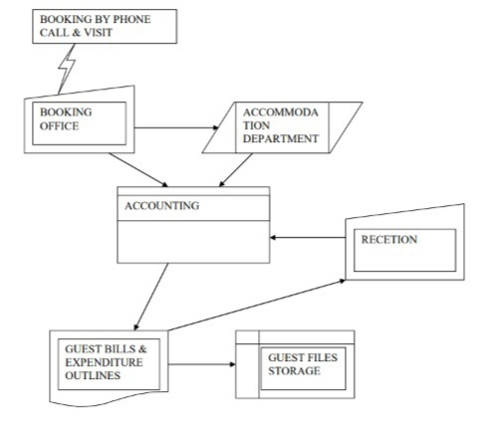

**Hotel Web Role**

According to our Research, the software will ensure that the people receive service on schedule. According to the platform's description, it serves as a "cloud-based information technology solution for the organizing, executing and assessing of Hotel guest in India.

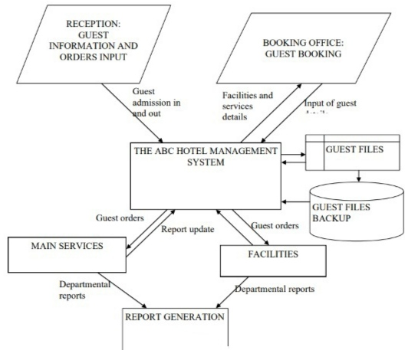

**Simulation/RESULT**

The database, object-oriented, and networking approaches are all used in the development of the suggested model. Because we have a large number of locations where we need to maintain entries in the database, we are utilizing JavaScript software, which is among the best and most user-friendly programs available for storing information. As the software, this project makes use of HTML CSS and JavaScript programming language. It is a web-based service that customers may access via a server as well as through a browser.

|  |  |  |
| --- | --- | --- |
| **HARDWARE** | | |
| **Processor** | **:** | 12th Gen Intel(R) Core(TM) i5-1235U 1.30 GHz |
| **Memory** | **:** | 256 MB RAM or above |
| **Cache Memory** | **:** | 128 KB or above |
| **Hard Disk** | **:** | 3 GB or above [at least 3MB free space required] |
| **SOFTWARE** | | |
| **Operating System** | **:** | Windows 11 |
| **Font-End Tool** | **:** | JavaScript, Html Css  Grid and flex |

Screenshot:-

1.

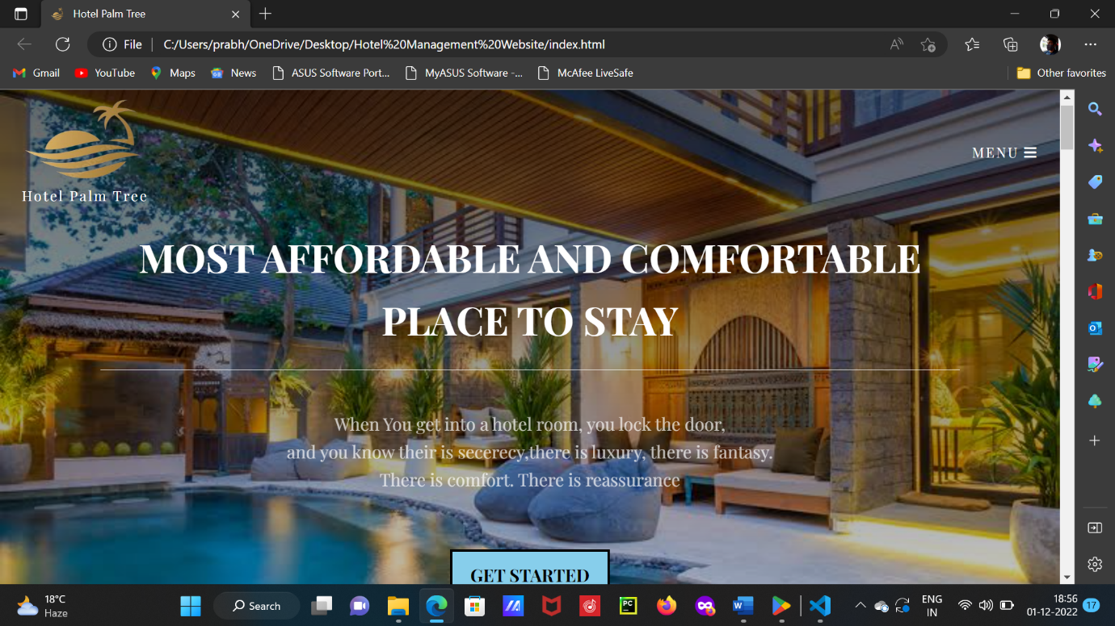

2.

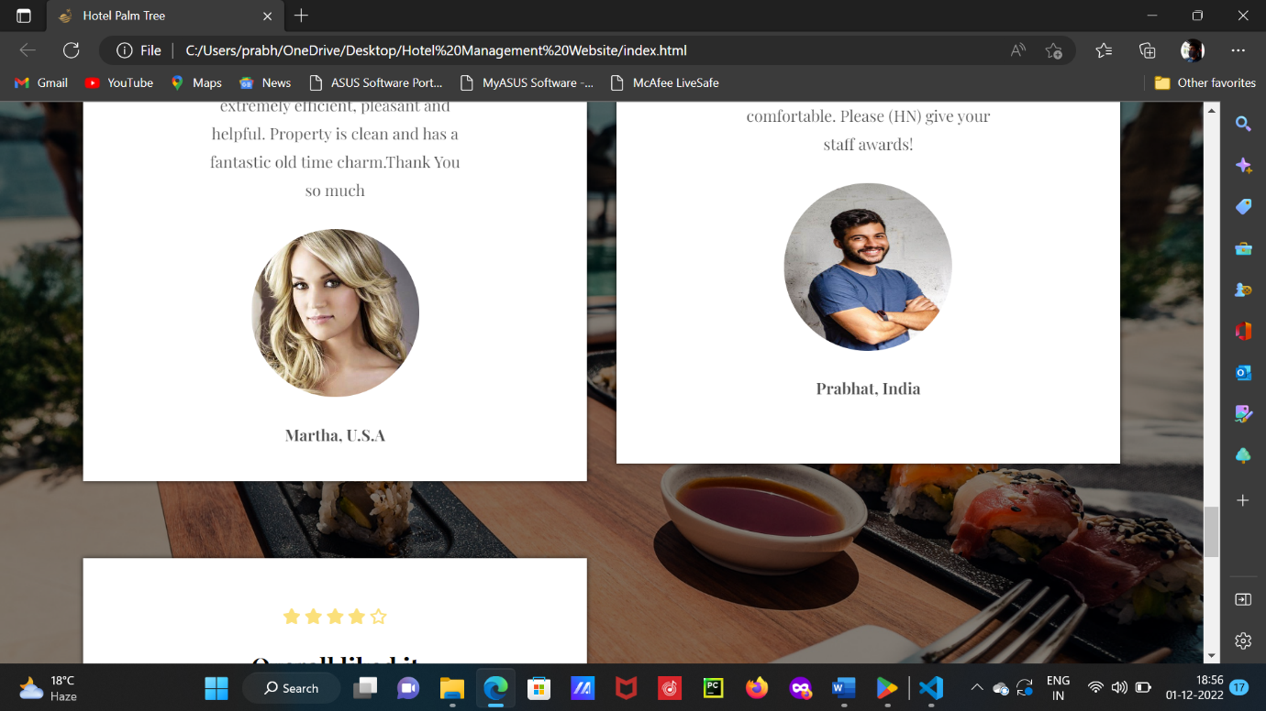

3.

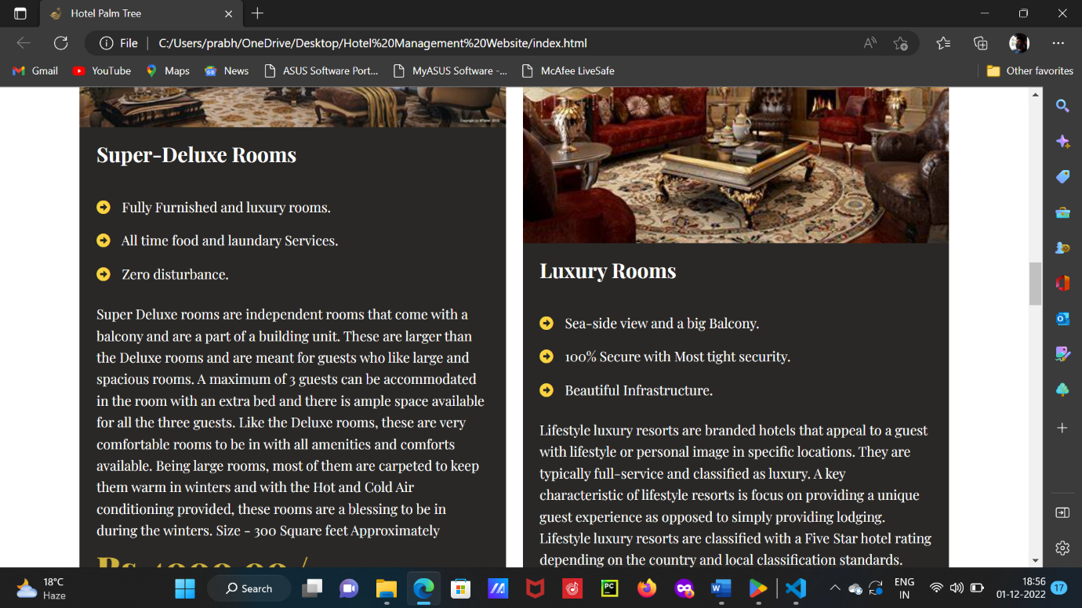

**Future Work**

In Future we will also contact some great restaurants and install them in our hotels , and will help them grow along with us. Will also give some benefits to our customers if they take our combo offer where they will room with room service of food and beverages which will be cost effective and pocket friendly to them . We will add an feature through which an user can directly book his/her room or dining for any meal just by viewing live in our website and will get to know directly which rooms are available and which table is available for dine in and can directly book his choice , he can also order food directly while booking his seat and thus can save time of sitting in the hotel waiting for food.

**Conclusion**

Finally, we have created a safe, user-friendly hotel administration system for the online space. Whether an Owner or a Customer, this system can care for each member. They will be able to manage their hotel effectively and support expansion without encountering any difficulties thanks to this system.

Since each user is given a user ID and password, there is no risk of any unwanted access, making this system entirely safe. It is simpler to use with online payment, booking, and cancellation. Therefore, utilising this technology will aid in lowering labour costs and in giving customers additional reasons to enjoy the hotel and return time and time again.

**Thank You!**